A Local Elevation Classification Method to Derive Subgrid Units for the ACME Atmospheric Model

The ACME atmospheric model uses a quadrilaterial grid structure. Each grid is discretized into subgrid units based on land surface elevation classes using an approach similar to the local land unit derivation method, which has been developed to derive subgrid units (land units) for the ACME land surface model. For each quadrilaterial grid, the elevation values are extracted from a 90 meter Digital Elevation Model (DEM) and an elevation-area profile relationship is derived. The elevation-area profile is discretized into a fixed number of distinct subgrid elevation classes between the minimum and maximum elevation within the grid based on values corresponding to certain percentiles such as 10th, 20th, 30th, 40th, 50th, 60th, 70th, 80th, 85th, 90th, and 95th as the intervals for the class breaks.
Shown in Figure 1 are examples of hexagonal grids instead of quadrilaterial grids with size equivalent to a 1-degree rectangular grid overlaying the DEM of Columbia River Basin and elevation-area profiles of two hexagonal grids selected to represent the mountainous and flat regions of the basin. The elevation-area profile plots clearly show that most of the changes in elevation occur in the highest 20% of the area of the hexagonal grids. Reducing the percentile interval ranges to 5 percentile after the 80th percentile can maximize the ability of the subgrid scheme to capture subgrid variability of orographic precipitation at high elevation mountainous areas (Figure 1), but increases the number of subgrid units.
Similar to the local land unit derivation method used for the ACME land surface model, a local eleven classification algorithm (Algorithm 1) is implemented to optimize the number of subgrid units for computational efficiency. For this purpose the minimum elevation range of each subgrid unit is set to be 100 meter. Any subgrid class with elevation range of less than 100 meter is merged with the neighboring subgrid class. As demonstrated for the subgrid classification scheme of the land surface model, this helps to maximize the subgrid variability of topography captured by the subgrid scheme by maximizing the number of subgrid units used to capture subgrid topographic variability in mountainous regions while minimizing the number of subgrid units in flat topographic regions. The method will be implemented in Python using ArcGIS functions. This requires the quadrilaterial grids to be represented as GIS polygons (shapesfile).

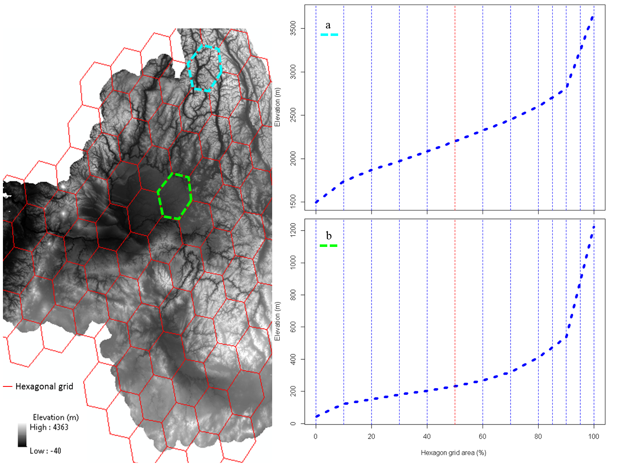
Figure 1: Hexagonal grids overlaying the Digital Elevation Model of the Columbia River Basin and elevation-area profile of hexagonal grids representing the mountainous (a) and flat (b) regions of the Columbia River Basin.

Algorithm 1
For each grid G:
Generate Elevation-area profile curve
Get minimum, maximum, and 10,20,30,40, 50, 60, 70, 80, 85, 90 and 95 percentile elevation values as initial elevation band threshold values (TV)
Calculate elevation ranges (ER) between each consecutive TVs For each elevation range (ER):
If ER < 100 m:
Combine class to next or previous class and update the corresponding TVs
Determine final class thresholds
Classify G into elevation subgrid units based on the final threshold values

