To join the ZOOM videoconference:
At the start time of your meeting, click on the link in your invitation to join via computer. You may be instructed to download the Zoom application if you have not used it before.
You may also join a meeting without clicking on the invitation link by going to join.zoom.us on any browser and entering the Meeting ID.
It is recommended that you use a headset with microphone, preferably one that connects to your computer by USB. You have an opportunity to test your audio at this point by clicking on “Test Computer Audio.” Once you are satisfied that your audio works, click on “Join audio by computer.”
If you are having trouble hearing the meeting, you can join via telephone while remaining on the video conference:
On your phone, dial the teleconferencing number provided in your invitation. Toll-free numbers are available for the U.S. and Canada. International and other numbers can be found here: https://zoom.us/u/ahE27bg4I
Enter the Meeting ID number (also provided in your invitation) when prompted using your touch-tone (DTMF) keypad.
You will then be prompted to enter your 2-digit participant ID to be associated with your computer.
You can find it at the top of your screen:
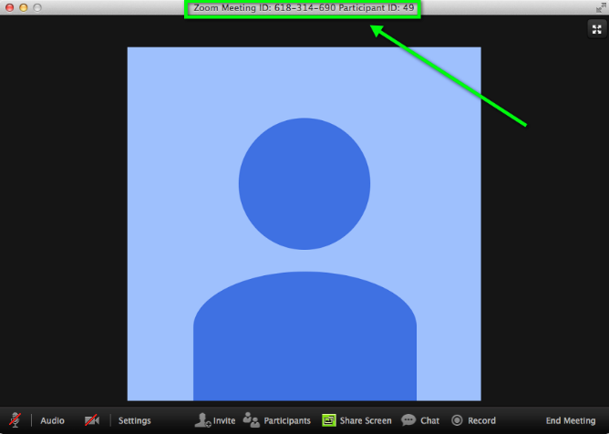
If you have already called into the meeting without entering your participant ID, you should enter the following on your phone to connect your Zoom meeting account and phone: # “participant ID” #

Participant controls in the lower left corner of the Zoom screen:
Using the icons in the lower left corner of the Zoom screen, you can:
- Mute/Unmute your microphone (far left)
- Turn on/off camera (“Start/Stop Video”)
- Invite other participants
- View Participant list – opens a pop-out screen that includes a “Raise Hand” icon that you may use to raise a virtual hand
- Change your screen name that is seen in the participant list and video window
- Share your screen
Somewhere on your Zoom screen you will also see a choice to toggle between “speaker” and “gallery” view. “Speaker view” shows the active speaker. “Gallery view” tiles all of the meeting participants.

Changing Your Name in a Zoom Meeting
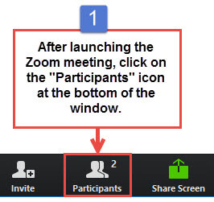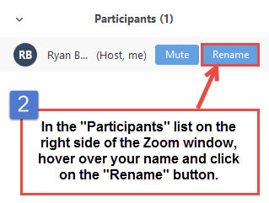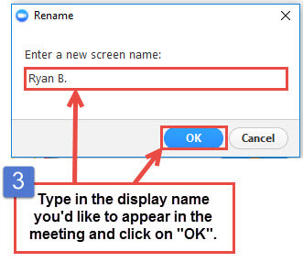
Audio/Video
The attendee controls appear at the bottom of your screen if you're not currently screen sharing.
Attendees have access to these features:
Mute / Unmute: Mute and unmute your microphone.
Audio Controls (click the ^ arrow next to Mute / Unmute): Allows you to change the microphone and speaker that Zoom is currently using on your computer, leave computer audio, and access the full audio settings.
Tip: Use the following keyboard shortcuts to mute or unmute yourself. You can also use push to talk if you want to unmute yourself by holding the spacebar.
- Windows: Alt + A
- Mac: Shift + Command + A
Start Video / Stop Video: Turns your camera on or off.
Video Controls (click the ^ arrow next to Start Video / Stop Video): Change cameras if you have multiple cameras, select a virtual background (if enabled), or access your full video settings.

Sharing
Zoom allows for screen sharing on desktop, tablet and mobile devices running Zoom.
- The host and attendee can screen share by clicking the Share Screen icon.
- The host does not need to grant screen share access for another participant to share their screen.
- The host can prevent participants from accessing screen share.

Sharing your screen
- Click the Share Screen button located in your meeting controls.
- Select the screen you want to share. You can also choose an individual application that is already open on your computer, the desktop, a whiteboard, or an iPhone/iPad.
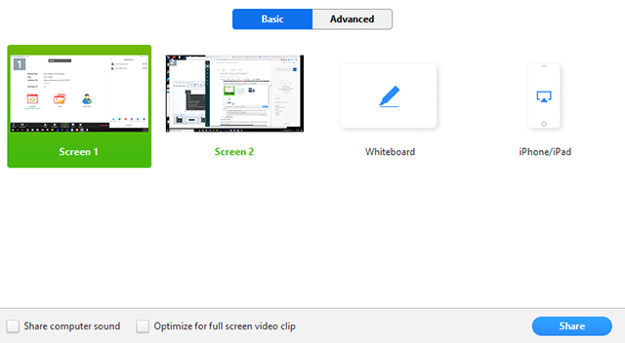
- (Optional) Enable these features:
  - Check Share Computer Sound: If you check this option, any sound played by your computer will be shared in the meeting.
  - Check Optimize for full screen video clip: Check this if you will be sharing a video clip in full screen mode. Do not check this otherwise, as it may cause the shared screen to be blurry.
- Click Share.
  - Zoom will automatically switch to full screen to optimize the shared screen view. To exit full-screen, click Exit Full Screen in the top-right corner or press the Esc key.
  - To disable automatic full screen when viewing a shared screen, disable this option in your desktop client settings: Enter full screen automatically when a participant shares screen.
  - When you start sharing your screen, the meeting controls will move into a menu that you can drag around your screen.
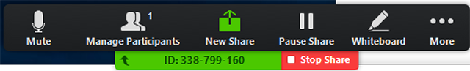
- Click “Stop Share” at any time to end screen sharing.
- Click on “More” for additional options, including “Hide Floating Meeting Controls” (hitting “esc” on keyboard will return floating meeting controls to screen)

