Quantifying the long-term changes of land water availability and their driving factors
2020 ESMD-E3SM PI meeting
Xiaoying Shi^{1*}, Yaoping Wang², Jiafu Mao¹, Ricciuto M. Daniel¹, Forrest M. Hoffman³, and Peter E. Thornton¹
¹Environmental Sciences Division and Climate Change Science Institute, Oak Ridge National Laboratory, Oak Ridge, TN, USA
²Institute for a Secure and Sustainable Environment, University of Tennessee, Knoxville, TN, USA
³Computational Sciences and Engineering Division and Climate Change Science Institute, Oak Ridge National Laboratory, Oak Ridge, TN, USA
ORNL is managed by UT-Battelle, LLC for the US Department of Energy
Motivation
✔ Fresh water is one of the key natural resources for human development and its availability affects water supplies,
agricultural yields, energy production, and infrastructure safety and operation. ✔ However, the investigation of long-term changes of water availability (WA) and quantification of their natural and
anthropogenic drivers remain
challenging.
Methods
✔ The GRACE reconstructions for both R and ΔTWS (Ghiggi et al., 2019; Humphrey and Gudmundsson, 2019), and the land WA is defined as
P – ET = R + ΔTWS
✔ 36 half-degree global offline factorial (S1 to S6) simulations of ELMv1.0 with CN or CNP configurations driven by 3 different climatic drivers (right table).
2
Simulations Climate forcing CNP and CN GSWP3 CRUNCEP PRINCETON
S1 Control, 1901-1920 climate cycling and 1850 conditions
S2 Transient climate only (CN and CNP)
S3 Transient climate and LULCC
S4 Transient climate, LULCC and CO₂
S5 Transient climate, LULCC, CO₂ and Ndep S6 Transient climate, LULCC, CO₂, Ndep and aerosol S2-S1 Climate only
S3-S2 LULCC only
S4-S3 CO₂ only
S5-S4 Ndep only
S6-S5 Aerosol only
ELM Experimental design
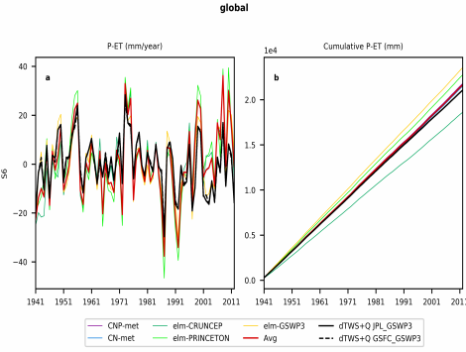
Observed and ELM simulated (S6) annual anomalies (mm) of land WA during 1941-2012
3
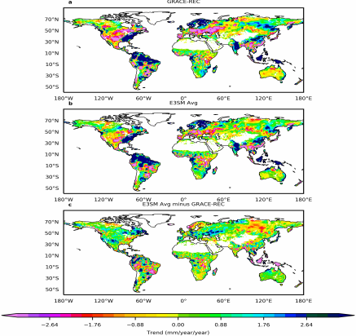
Spatial distributions of observed and ELM simulated (S6) WA trends and their differences (1941-2012)
4
All factors Climate effects
_{CNP-met} CN-met
_{CNP-met} CN-met
ELM
CRUNCEP ELM
ELM
PRINCETON
ELM
CRUNCEP ELM
ELM
PRINCETON
_{GSWP3} AVG
_{GSWP3} AVG
Spatial distributions of ELM simulated all-factor (left) or climate (right)
S6-S1 WA trend (CNP-met, CN-met, elm-CRUNCEP, elm-PRINCETON, elm-GSWP3 and Avg)
induced WA changes
₅ S6-S1 WA trend (CNP-met, CN-met, elm-CRUNCEP, elm-PRINCETON, elm-GSWP3 and Avg) S2-S1 Clim olny trend (CNP-met, CN-met, elm-CRUNCEP, elm-PRINCETON, elm-GSWP3 and Avg)
CO₂ effects Ndep effects
_{CNP-met} CN-met
_{CNP-met} CN-met
ELM
CRUNCEP ELM
ELM
PRINCETON
ELM
CRUNCEP ELM
ELM
PRINCETON
_{GSWP3} AVG
_{GSWP3} AVG
Spatial distributions of ELM simulated CO₂ (left) or Ndep (right) induced
S6-S1 WA trend (CNP-met, CN-met, elm-CRUNCEP, elm-PRINCETON, elm-GSWP3 and Avg)
WA changes
S4-S3 CO₂ trend (CNP-met, CN-met, elm-CRUNCEP, elm-PRINCETON, elm-GSWP3 and Avg) S5-S4 Ndep trend (CNP-met, CN-met, elm-CRUNCEP, elm-PRINCETON, elm-GSWP3 and Avg) 6
LULCC effects Aerosol effects
Spatial distributions of ELM simulated LULCC (left) or Aerosol (right)
S6-S1 WA trend (CNP-met, CN-met, elm-CRUNCEP, elm-PRINCETON, elm-GSWP3 and Avg)
induced WA changes
₇ S6-S5 Aerosol trend (CNP-met, CN-met, elm-CRUNCEP, elm-PRINCETON, elm-GSWP3 and Avg) S3-S2 LULCC trend (CNP-met, CN-met, elm-CRUNCEP, elm-PRINCETON, elm-GSWP3 and Avg)
Summaries of component (left) and factorial (right) contributions to WA
By component By forcing
8
Spatial distributions of dominant component (left) or factor (right) driving the WA changes
9
Summary
✔ Both observation-based and ELM simulated global-averaged annual WA showed significant increasing trends for the 1941-2012 period;
✔ ELM basically captured the changing sign and magnitudes of the spatial patterns of the WA trends, albeit with differences for ecoregions including the cropland, wetlands and deserts;
✔ For each component of WA, the precipitation controlled the WA changes across most global areas; but ET demonstrated primary local effects, especially over the temperate grassland and shrubland, deserts and wetlands;
✔ Although the climate change was identified to determine the long-term trends of WA, anthropogenic CO₂ concentration, nitrogen deposition, land use/land cover changes, and aerosol induced significant WA changes at regional scales. For example, CO₂ demonstrated evident effects over the boreal forests, and LULCC mattered over west Europe and African tropical forests;
✔ The impacts of different factors on the changes of WA are sensitive to the model configurations and climatic forcings.
10

