Improving the simulations of biomass burning smoke and anthropogenic dust in E3SM
Xiaohong Liu¹, Zheng Lu¹, Ziming Ke¹, Allen Hu¹, Jiwen Fan², Kai Zhang², and Po-Lun Ma²
¹Texas A&M University, ²PNNL
Motivation
• Goal: to interactively calculate fire plume injection heights based on fire properties and ambient meteorological conditions in the model.
• For ne30 res. application
• In one ne30 grid, difference in fire
intensities of many fires (fire size, heat release) leads to different injection
heights – the need for describing the fire intensity distribution.
ne30 grid
• Physics of 1D plumerise model • Embedded in host model (WRF Chem, E3SM, etc.)
• Solving 6 governing equations of �, T, and m.m.r. of cloud hydrometeors. • Inputs for initial conditions: fire size
and fire heat release, and ambient conditions (T, �, �, U, V, qv)
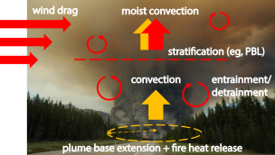Paugam et al., 2016
Approach – Scaled-FRP and FRP×10 in this study • Four FRP bins + MODIS observations
• 0~10MW : 14% of BB emis.
• 10~100MW: 66% of BB emis.
• 100~500MW: 17% of BB emis.
• >500MW: 3% of BB emis.
• New emission files
• Total emissions of BC and POM are partitioned to these four FRP bins as four sectors
(emission∝ total FRP, Ichoku and Kaufman, 2005 ). • Note: vert. dist. of BB aerosols are still prescribed in the files.
F
D
• In scaled-FRP method, we need to find maximum FRP over a certain area or biome and long periods (Val Martin et al., 2012). MaxFRP corresponding to 1 km² of fire size
• In our study, MaxFRP is a function of (GFED regions, PFTs, months)
• We incorporate the LUT in the code and calculate MaxFRP before the plumerise calculation.
GFED geographic regions
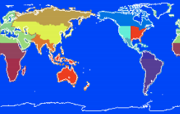
P
Preliminary results
Fire emissions % of four categories
Calculated and prescribed BC profiles
FRP: <10 MW FRP: 10-100 MW
FRP: 100-500 MW FRP: >500 MW
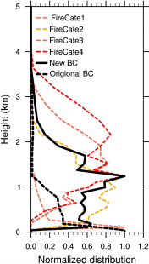
S. Africa
Jan.7,2000
plumerise
old
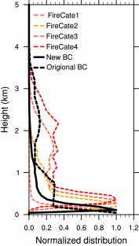
N. Africa Jan. 7 2000
Preliminary results • Burden of mode 4 (mg/m²)
• Surface BC/POM emissions are turned off
• Higher burden over SE. Asia, Australia, and Southern Africa.
• Lower burden over N. Africa
Plumerise Original
Anthropogenic dust emission
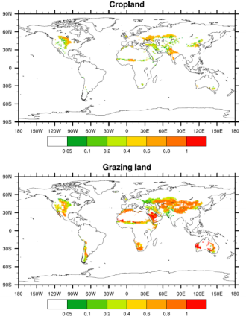
Only at bare soil (Zender et al. 2003 ) Landuse (year 2010, from HYDE 3.2.1)
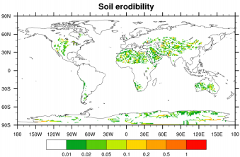
Only regions with
leaf area index<0.5
are plotted
Approach to account for dust emissions due to land use
(anthropogenic dust) by modifying the soil erodibility S in
dust emission parameterization:
S_{new} = S_{default} + C * f_{land_use}
f_{land_use}: landuse fraction from Goldewijk et al. (2017): Historical
Database of the Global Environment (HYDE version 3.2). Resolution
at 0.0833 degree (~9 km), 10,000 BCE to 2015 CE
Experimental design
• Zender et al. (2003) dust emission scheme is used, with SST and sea ice prescribed
Experiments Soil erodibility (S)ª Leaf and stem area index threshold (L+S)_{t}
Threshold of S (S_{t})
• Where C represents tuning factor for
Default Geomorphic S (natural) 0.3 0.1
Baseline Geomorphic S (natural) 0.5 0.001 _{LU_1} Geomorphic S (natural) plus
_{land use fraction (C=1)} 0.5 0.001
_{LU_001} Geomorphic S (natural) plus
_{land use fraction (C=0.01)} 0.5 0.001
• Model results are 2010-2012 averages with 2009 as spin-up
anthropogenic vs. natural dust emissions
Emissions Difference between LU_001 and Baseline
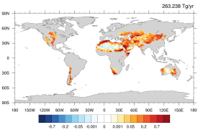^{263.2} 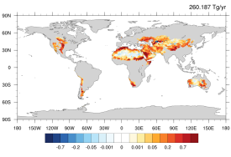_{65.0} 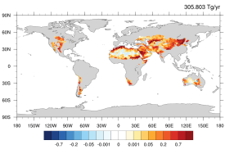76.5 Annual Dec/Jan/Feb Mar/Apr/May
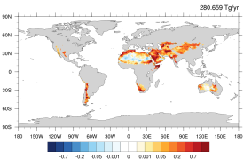^{70.2} 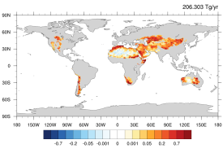51.6
_{Jun/Jul/Aug} Sep/Oct/Nov
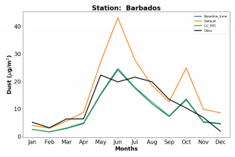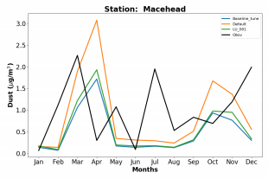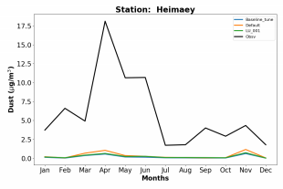_{63.4˚N, 20.3˚W} ^{13.2˚N, 59.4˚W} 53.3˚N, 9.9˚W 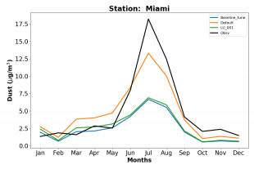25.8˚N, 80.3˚W 28.2˚N, 177.4˚W 28.3˚N, 16.5˚W

